**USER PROTOCOL**

**ID 5027710**

**Grounds Maintenance Services Contract**

**Start Date: 1 May 2024**

**End Date: 30 April 2030**

**(Including Extensions)**

Contents

1 Background 2

2 Scope of Services 3

3. Contract – Lots 4

4 Contract Duration 6

5 Pricing 6

6 Contractor Contact Details 6

7 Service Provision 7

8 Contract Management 8

# 1 Background

* 1. The Grounds Maintenance Services Contract has been established for the bodies listed in Annex A. These bodies are defined as the ‘Client’ in the Specification Schedule; accompanying Conditions of Contract and the Supplementary Conditions of Contract.
  2. All procurement and contract documentation is provided within the project documents on the CPD website. Details on how to access pricing information is provided in Section 5. If you need to contact CPD please contact [collaboration.cpd@finance-ni.gov.uk](mailto:collaboration.cpd@finance-ni.gov.uk)
  3. The Contract has been awarded on the basis of an output specification (see Specification Schedule on the CPD Website). Prices provided for each site listed on the completed Pricing Schedule are for the range of services within the Specification Schedule.
  4. Unless otherwise advised, each Client using the Services under this Contract will do so independently, therefore the Client is responsible for:
* Raising a Purchase Order;
* Paying invoices within 30 days; and
* Managing the Contractor’s performance.

1.5 The Contractor is responsible for providing the contracted Services in accordance with the output-based Specification, invoicing each Client and handling complaints directly with each Client.

1.6 This protocol should be read in conjunction with the Specification Schedule to ensure;

* full compliance with this Contract; and
* that each contract is managed appropriately.

# 2 Scope of Services

2.1 The Contract covers a range of services including:

* Grass Cutting
* Fallen Leaf and Litter Removal
* Ditches, Drainage Channels, Ponds and Watercourses
* Tree Work
* Hedges
* Shrubs and Shrub beds
* Estate Signage
* Pavements, Car parks, Hardstands and Roadways within Site Boundaries
* Invasive Species

2.2 Further detail on the services and standards is included in the Specification Schedule which is listed within the project documents on the CPD website.

# 3. Contract – Lots

3.1 The Contract covers 3 Lots and awarded to the below;

* Lot 1 – Northern Area – R&M GreenKeeper Ltd. - BPA Number 6100076907
* Lot 2 – Southern Area – Landscaping Centre Ltd. T/A ID Verde – BPA Number 6100076908
* Lot 3 - LANDSCAPING CENTRE LTD

The diagram below provides details of the areas covered within each Lot.

Lot 1 - Northern Region,

Lot 2 - Southern Region and

Lot 3 - National Museums Northern Ireland.

Yellow shaded area indicates Northern Area – Lot 1;

White area indicates Southern Area – Lot 2

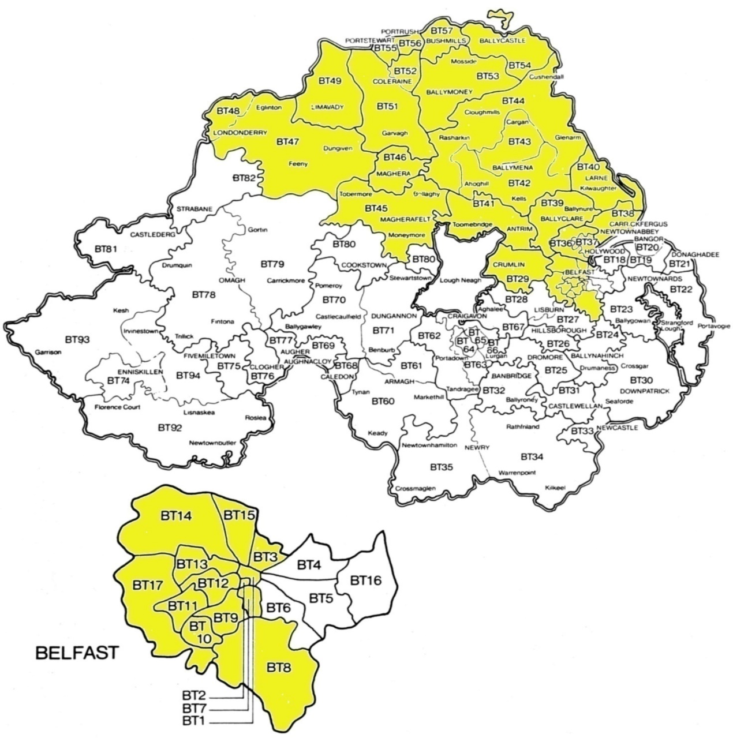Applicable Postal Codes for Lot 1 & Lot 2

|  |  |
| --- | --- |
| Lot 1 – Northern Area | Lot 2 – Southern Area |
| BT1- BT3; BT7- BT15, BT17; BT29; BT36- BT57; | BT4 - BT6; BT16 BT18 – BT28; BT30 – BT35; BT60 – BT94 |

Lot 3 – National Museums Northern Ireland

|  |  |
| --- | --- |
| National Museums NI | 153 Bangor Rd, Cultra, Holywood, BT18 0EU |
| Cultra Manor | 153 Bangor Rd, Cultra, Holywood, BT18 0EU |
| Ulster Transport Museum | 153 Bangor Rd, Cultra, Holywood, BT18 0EU |
| Ulster American Folk Park | 2 Melon Rd, Omagh, BT78 5QU |
| Wilson House | 28 Sprout Road, Strabane, BT82 8NB |
| Ulster Museum | Botanic Gardens, Belfast, BT9 5AB |

# 4 Contract Duration

4.1 The Contract commences on 1 May 2024

The initial contract period is 3 years with two optional extension periods of up to 24 months and up to 12 months. The maximum contract period shall be 6 years including extension options.

# 5 Pricing

# 

5.1 This contract has been priced on the basis of maintaining each site listed on the Pricing Schedule to the standard specified within the Specification Schedule.

5.2 Orders placed using AccountNI will use the catalogue which sets out the monthly charge for each site. Unit prices are also attached for the ad-hoc services.

5.3 Costs for additional buildings / services will be at rates commensurate with tendered rates for sites of a similar size.

5.4 Non AccountNI users can request the completed pricing schedules from CPD by forwarding a Non-Disclosure Agreement (NDA) form. A template NDA is provided within the list of project documents on the CPD website.

# 

# 6 Contractor Contact Details

6.1The Contractor’s contact details for all Lots are provided below.

|  |
| --- |
| Contractor’s contact details **Lot 1** |
| **R & M Greenkeepers**  Address: **Unit C1 Kilcronagh Bus. Park, Cookstown, BT80 9HG**  Point of Contact: **Kyle Smyth**  Telephone Number: **02886758971 / 07747755848**  Email Address: [**kyle@rmgreenkeepers.com**](mailto:kyle@rmgreenkeepers.com) |

|  |
| --- |
| Contractor’s contact details **Lot 2** |
| **Contractor’s contact details Lot 2**  **Landscaping Centre Ltd**  Address: **181b Templepatrick Road, Ballyclare, BT39 0RA**  Point of Contact: **Barry Mott**  Telephone Number: **Office: 02893345610 Mobile: +447585649173**  Email Address: [barry.mott@idverde.co.uk](mailto:barry.mott@idverde.co.uk) |

|  |
| --- |
| Contractor’s contact details **Lot 3** |
| **Landscaping Centre Ltd**  Address: **181b Templepatrick Road, Ballyclare, BT39 0RA**  Point of Contact: **Trevor Spence**  Telephone Number: **02893345610**  Email Address: [**trevor.spence@idverde.co.uk**](mailto:trevor.spence@idverde.co.uk) |

# 7 Service Provision

7.1 Unless otherwise agreed, the Contractor should report directly to the reception area to formally notify the premises officer (or equivalent) of their arrival. Specific site procedures should be made known to the Contractor at this point.

7.2 On completion of the work, the Contractor should provide a work completion note/statement, detailing the Services that have been provided.

7.3 The completion note/statement should state the date the work was completed be signed by the Client/premises team representative (or equivalent) to certify that the services have been carried out satisfactorily. The work completion note should include the Client representatives name and job title in addition to their signature to allow for verification of services delivered.

* 1. The Client may require completion notes to be provided each month to support the Contractor’s invoice. This will be confirmed by each Client within the Order Form.
  2. Payment must be made to the Contractor within 30 days of receipt of a valid invoice.
  3. Invoicing queries must be dealt directly with the Contractor.

# Contract Management

8.1 Please see the Commercial Conditions of Contract Schedule 3 Contract management schedule for full details in relation to contract management and management information requirements.

* 1. Each Client will be responsible for managing the day to day operations of the Contract. Issues arising from poor performance will be managed by the Client’s Site Representative directly with the Contractor.

8.3 The Contractor will provide Clients with monthly Management Information (MI) Reports to monitor the Contract. Clients will meet with the Contractor on a quarterly basis to discuss their performance. The frequency of contract review meetings can be amended by each client.

# Frequently Asked Questions

**Q.** Can other bodies be added to the Contract?

**A.** No. Only those bodies listed in the table at Annex A can use this Contract.

----------------------------------------------------------------------------------------

**Q.** Can sites be removed or added to the Contract?

**A.** During the life of the Contract, sites (occupied/owned by those bodies within the scope of the Contract) may be added or removed.

Where new sites are added the price for these sites will be calculated on the basis of pricing information submitted in the Tender (ie, similar sized sites should attract similar rates). Where sites are being removed from the Schedule, you should give the Contractor as much notice as possible (but no less than 3 months notice).

-----------------------------------------------------------------------------------------

**Setting up an Account**

**Q.** If I am listed on the Contract do I need to contact CPD to set up my Account?

**A.** No, the Services have been contracted for the sites listed within the Pricing Schedule. The Contractor will be in touch with you to agree the Schedule of Work. A catalogue has been set up on AccountNI to allow Departments to order the services.

If you require the completed Pricing Information, you should complete the Non-Disclosure Agreement form which is included within the project documents listed on the CPD website and forward it to the address on the proforma.

**---------------------------------------------------------------------**

**Pricing**

**Q.** My organisation is listed in Annex A below, but my site isn’t listed on the Pricing Schedule, how do I obtain prices for Grounds Maintenance Services?

**A.** Prices for the Contract are based on the sites listed within the Pricing Schedules (included within the project documents on the CPD website). Costs for additional sites / services will be at rates commensurate with tendered rates for sites of a similar size. To obtain a price for your site you should:

* Contact the Contractor to carry out a survey for your site and provide a price. In providing a price, the Contractor should identify which building on the original pricing schedule has been used as a benchmark.
* Agree the price with the Contractor and hold this information for audit purposes.
* If there is a dispute over the proposed price, you should contact CPD.

As above, if you do not have a copy of the tendered Prices you can request these from CPD by completing a Non-Disclosure Agreement (NDA) and forwarding this to CPD. A template NDA is provided within the list of project documents on the CPD website (this includes the email address for returns).

**--------------------------------------------------------------**

**Invoicing and Payments**

**Q**. What are the payment arrangements?

**A.** Invoices will be submitted by the Contractor on a monthly basis and paid promptly by the Client. However, if the invoice contains an error (such that the invoice cannot be processed by the Client for payment), the Client will reject the invoice and return it to the Contractor for correction. In such a case, time for payment of the rejected invoice will not start to run until a fully corrected valid invoice is received by the Client. (Note: All invoices must be made payable to the Contractor and not to any nominated sub-contractor of the Contractor).

---------------------------------------------------------------------------------------

**Q.** What information should be included on the Invoice?

**A.** Invoices shall show the site detail and the period covered (i.e. which month). Invoices should include a detailed breakdown of all charges and a clear indication of what works have been carried out for which payment is claimed. The invoice must include the invoice number, date, purchase / job order number, services provided, contract price, contract reference, site asset number, site name and settlement discount (if applicable).

----------------------------------------------------------------------------------------

**Q.** Should payment be made if the work has not been signed off?

**A.** Invoices shall only be paid where the work has been carried out to the satisfaction of the Client and is not in dispute. For undisputed invoices, payment shall be made by the Client in accordance with the Late Payment of Commercial Debts (Interest) Act 1998 (as amended by the 2013 Regulations) no later than 30 days of receipt.

----------------------------------------------------------------------------------------

**Q.** I am an AccountNI user, how do I raise a Purchase Order (PO)?

**A.** The elements of this contract will be available to order through the iProcurement Catalogue. In the Main Store search field in iProcurement, enter the Description or Supplier Item Code for the goods/service required. To ensure that accurate management information in relation to this contract is captured, POs must be created using the iProcurement Catalogue.

For AccountNI users the BPA numbers for the contracts are:

Lot 1 BPA 6100076907

Lot 2 BPA 6100076908

Lot 3 – Does not use Account NI

----------------------------------------------------------------------------------------

**Q.** As an AccountNI user, are there any specific invoicing requirements?

**A.** Yes, Account NI has an **e-invoicing** solution in place and contracted suppliers are required to meet the following minimum requirements in relation to the submission of Invoices and Credit Notes:

1. Invoices and Credit Notes must be in a structured pdf format

Account NI require that invoices are received directly via email from the supplier’s accounting system.  If however the accounting system cannot produce a structured/tagged PDF directly, various other suitable methods are acceptable, including, e.g.

* PDF printer driver software such as CutePDF or Bullzip.
* MS Office has a facility to generate structured/tagged pdfs.

1. Invoices and Credit notes must quote a valid Account NI Purchase Order Number

Invoices and Credit Notes must be emailed directly to Account NI at the following address: - [invoices@accountni.gov.uk](mailto:invoices@accountni.gsi.gov.uk)

Q. As an AccountNI user, when should I process a receipt?

A. Departmental Requisitioners should process the receipt in iProcurement in a timely manner and before the invoice is received in order to maximise the benefits of the e-invoicing solution.

**Complaint Resolution**

**Q.** Who do I contact if I have a problem with the standard of Services or performance of the Contractor?

**A.** Any complaints/issues with the operational Services should be addressed to the Contractor staff on site. You should not sign the completion note for the Services performed unless you are satisfied that the Services have been completed to the required standard. Any other complaints should be referred to the Contractor’s representative. Contact points for the Contractor are provided within the User’s protocol on the CPD website.

-----------------------------------------------------------------------------------------

**Q.** What is the escalation procedure if a complaint remains unresolved?

**A.** In the event that complaints cannot be resolved between the Client’s Site Representative and the Contractor, the Client’s Site Representative should escalate this to a Contractor’s next escalation point for resolution. The Contractor shall meet the Client’s Representative and provide a report on the compliant and provide a detailed plan on the appropriate action required to resolve issues to ensure compliance with the specification schedule. If the issue remains unresolved the Client’s Representative shall contact CPD who will review the complaint and advise how the matter is progressed.

**Annex A – List of Participating Bodies**

|  |
| --- |
| **DEPARTMENT (and Agencies of Department/Arms Length Body/Independent Body)** |
| Department for Communities |
| Department for Infrastructure |
| Department for the Economy |
| Department of Agriculture, Environment and Rural Affairs |
| Department of Education |
| Department of Finance |
| Department of Justice |
| The Executive Office |
| Agri-Food Biosciences Institute (AFBI) |
| Invest Northern Ireland |
| National Museums Northern Ireland |
| Northern Ireland Audit Office |